Chapter 3 Exercises
Enter and run your own SELECT statements
In these exercises, you’ll enter and run your own SELECT statements. To do that, you can open the script for an example that is similar to the statement you need to write, copy the statement into a new Worksheet window, and then modify the statement. That can save you both time and syntax errors.
- Write a SELECT statement that returns three columns from the Vendors table: vendor_name, vendor_contact_last_name, and vendor_contact_first_name. Then, run this statement.
Next, add code to this statement so it sorts the result set by last name and then first name. Then, run this statement again. This is a good way to build and test a statement, one clause at a time.
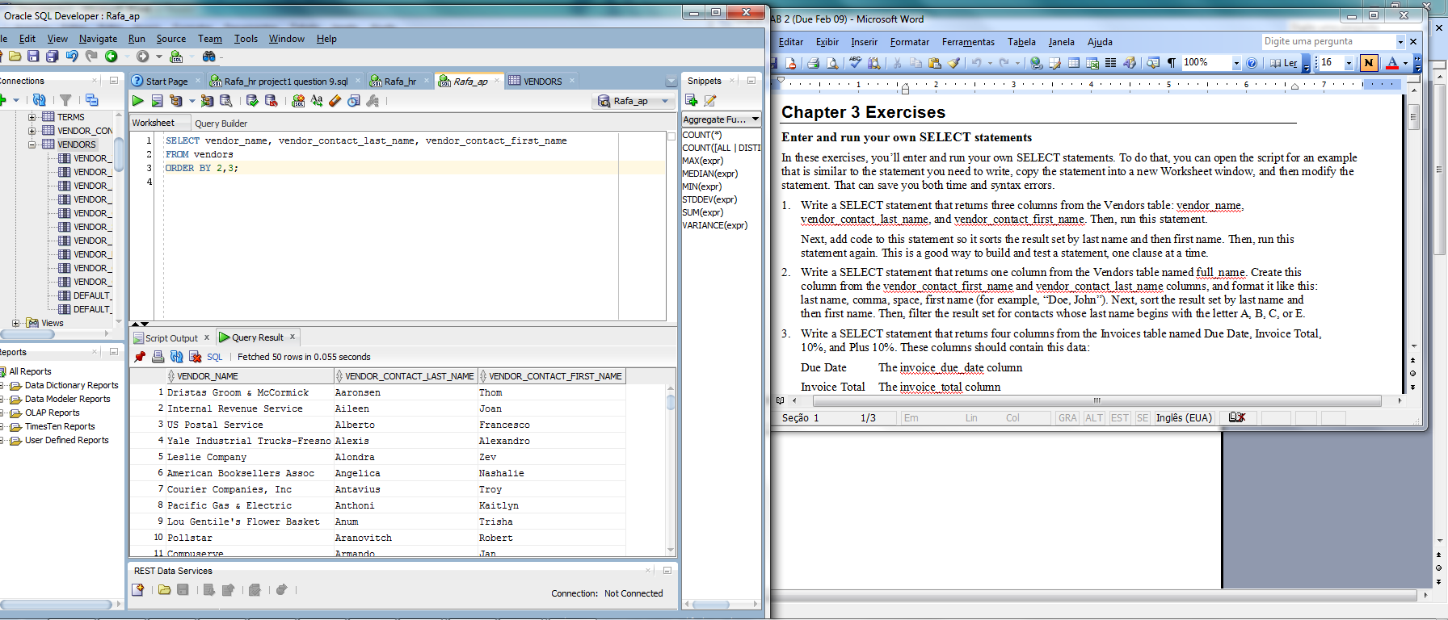
- Write a SELECT statement that returns one column from the Vendors table named full_name. Create this column from the vendor_contact_first_name and vendor_contact_last_name columns, and format it like this: last name, comma, space, first name (for example, “Doe, John”). Next, sort the result set by last name and then first name. Then, filter the result set for contacts whose last name begins with the letter A, B, C, or E.
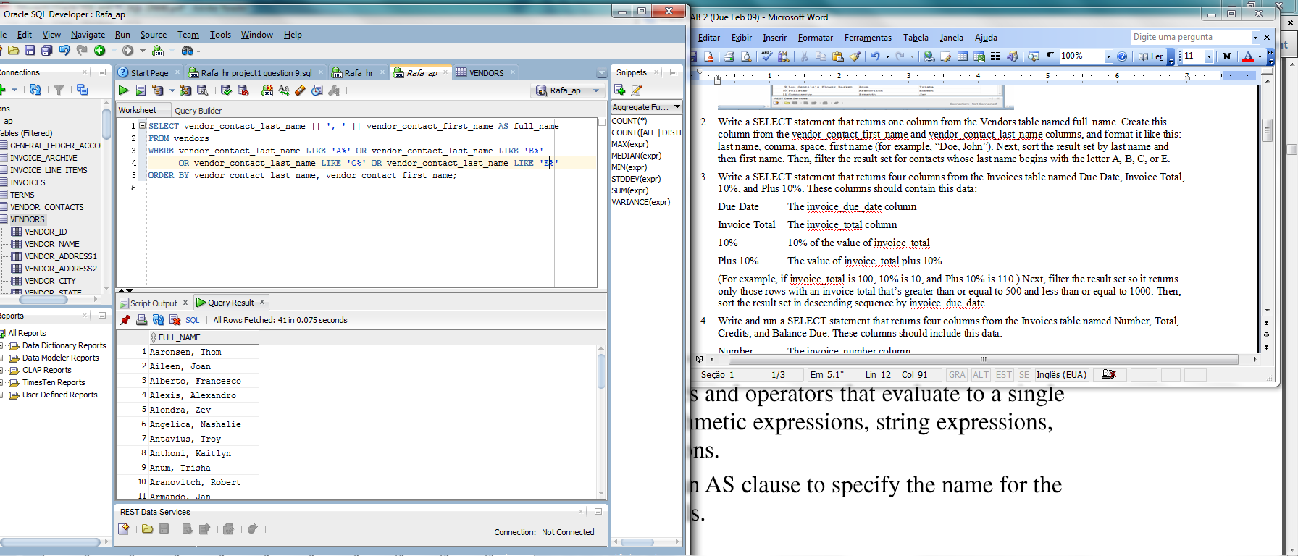

- Write a SELECT statement that returns four columns from the Invoices table named Due Date, Invoice Total, 10%, and Plus 10%. These columns should contain this data:
Due Date The invoice_due_date column
Invoice Total The invoice_total column
10% 10% of the value of invoice_total
Plus 10% The value of invoice_total plus 10%
(For example, if invoice_total is 100, 10% is 10, and Plus 10% is 110.) Next, filter the result set so it returns only those rows with an invoice total that’s greater than or equal to 500 and less than or equal to 1000. Then, sort the result set in descending sequence by invoice_due_date.
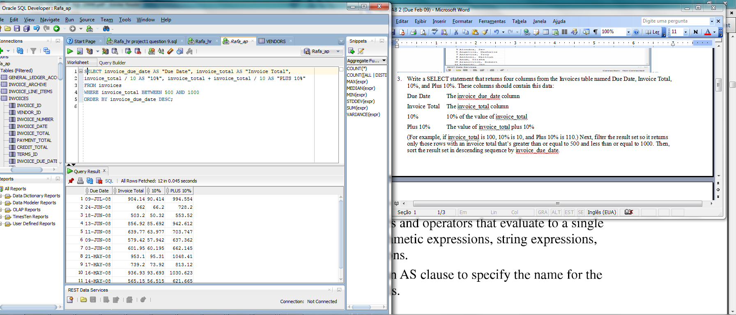
- Write and run a SELECT statement that returns four columns from the Invoices table named Number, Total, Credits, and Balance Due. These columns should include this data:
Number The invoice_number column
Total The invoice_total column
Credits Sum of the payment_total and credit_total columns
Balance Due Invoice_total minus the sum of payment_total and credit_total
Next, filter for invoices with a balance due that’s greater than or equal to $500. Then, sort the result set by balance due in descending sequence. Last, use the ROWNUM pseudo column so the result set contains only the rows with the 10 largest balance dues.
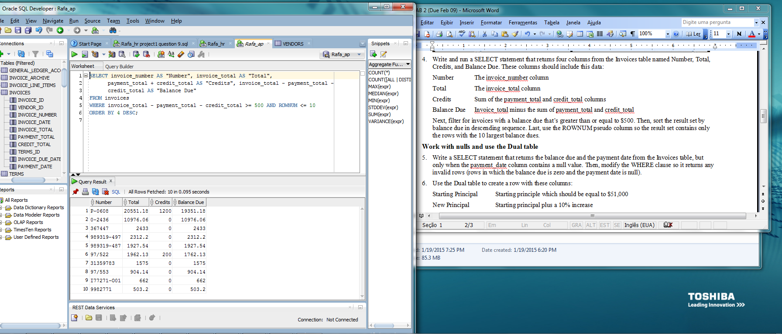
Work with nulls and use the Dual table
- Write a SELECT statement that returns the balance due and the payment date from the Invoices table, but only when the payment_date column contains a null value. Then, modify the WHERE clause so it returns any invalid rows (rows in which the balance due is zero and the payment date is null).
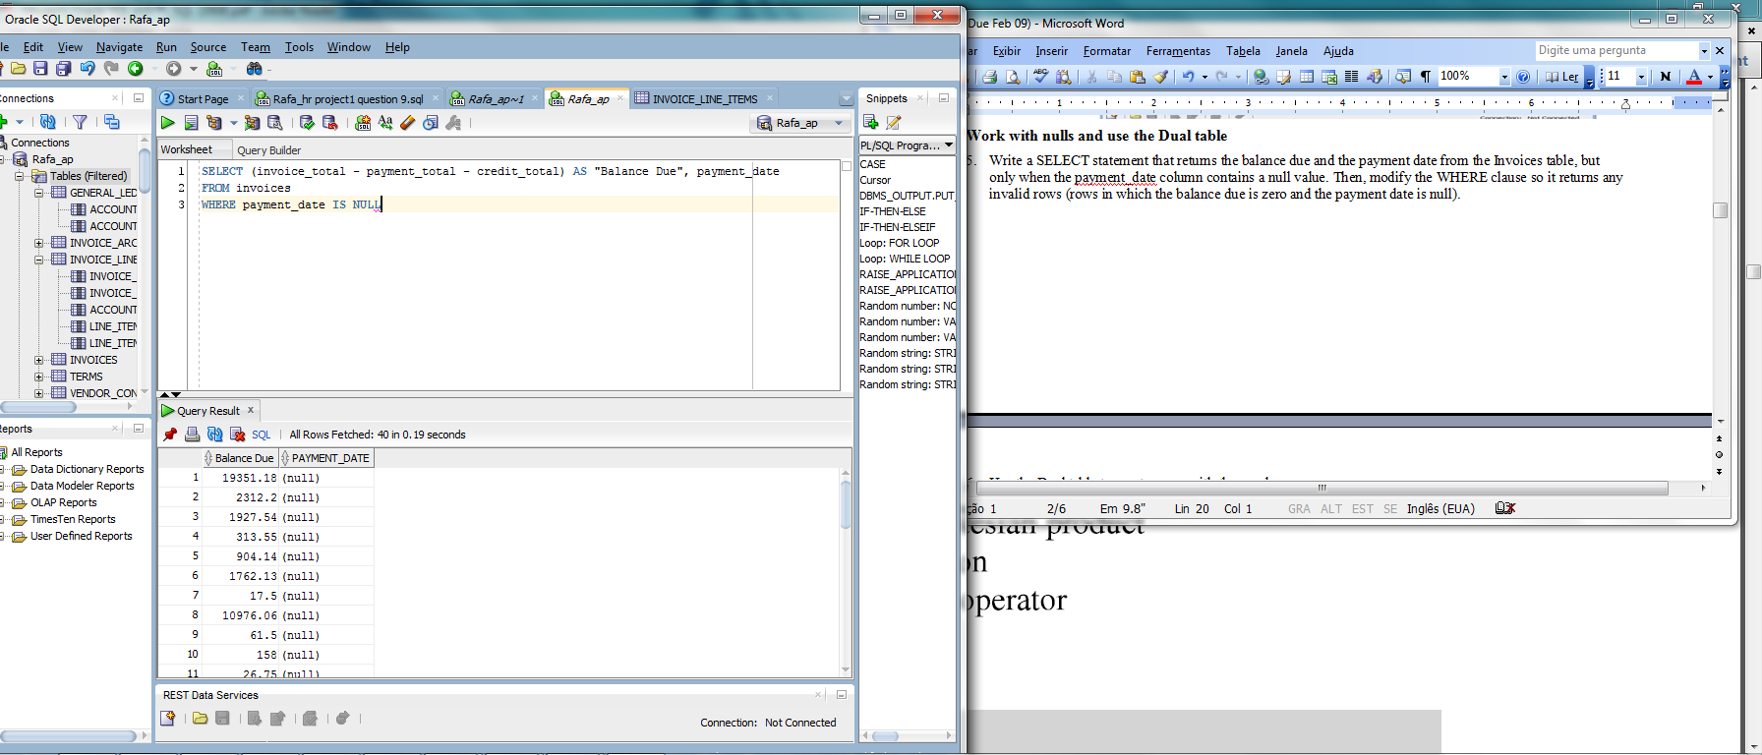

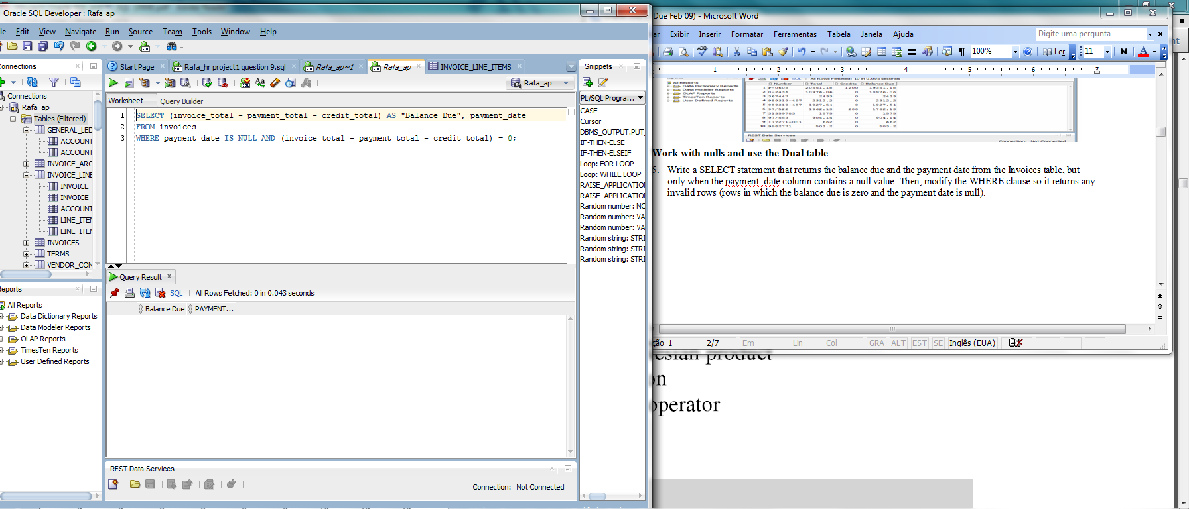

- Use the Dual table to create a row with these columns:
Starting Principal Starting principle which should be equal to $51,000
New Principal Starting principal plus a 10% increase
Interest 6.5% of the new principal
Principal + Interest The new principal plus the interest (add the expression you used for the new principal calculation to the expression you used for the interest calculation)
Now, add a column named “System Date” that uses the TO_CHAR function to show the results of the SYSDATE function when it’s displayed with this format:
'dd-mon-yyyy hh24:mi:ss'
This format will display the day, month, year, hours, minutes, and seconds of the system date, and this will show that the system date also includes a time.
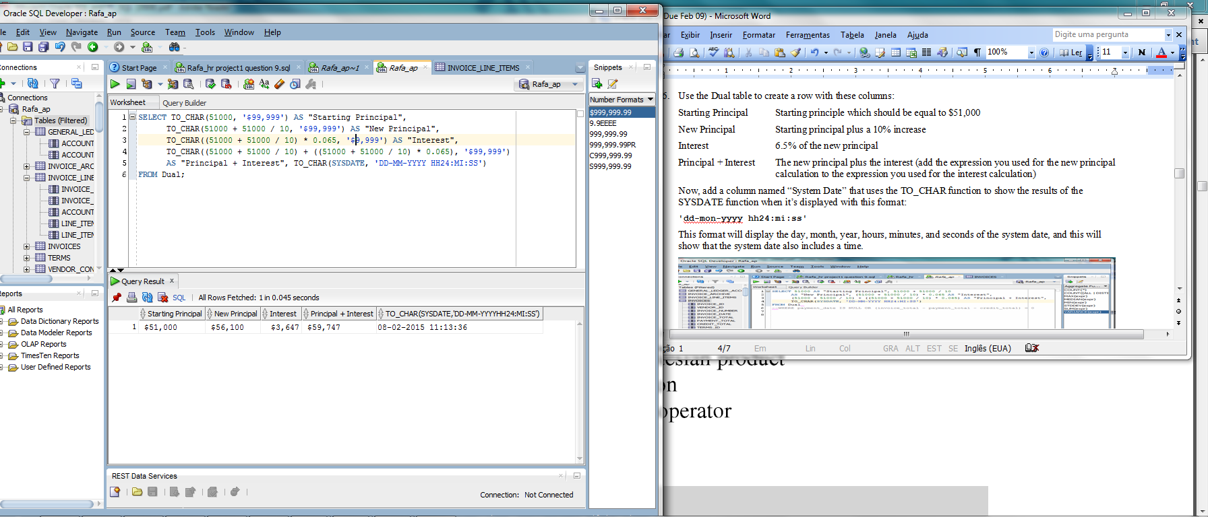

Chapter 4 Exercises
- Write a SELECT statement that returns all columns from the Vendors table inner-joined with all columns from the Invoices table.
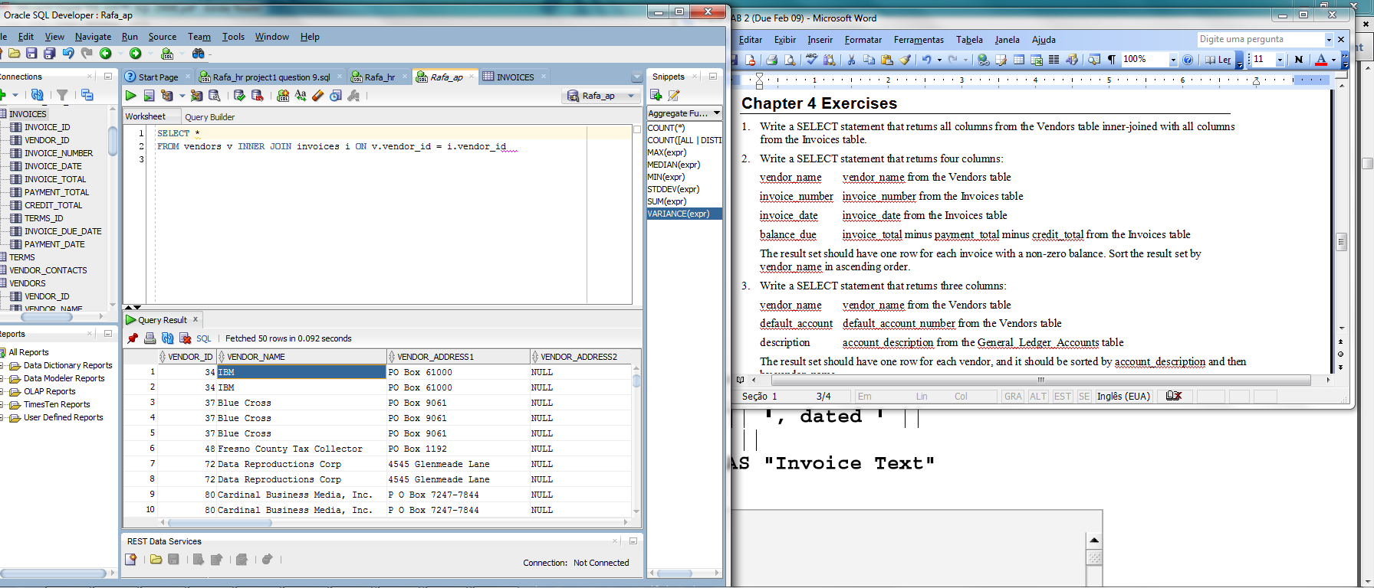

- Write a SELECT statement that returns four columns:
vendor_name vendor_name from the Vendors table
invoice_number invoice_number from the Invoices table
invoice_date invoice_date from the Invoices table
balance_due invoice_total minus payment_total minus credit_total from the Invoices table
The result set should have one row for each invoice with a non-zero balance. Sort the result set by vendor_name in ascending order.
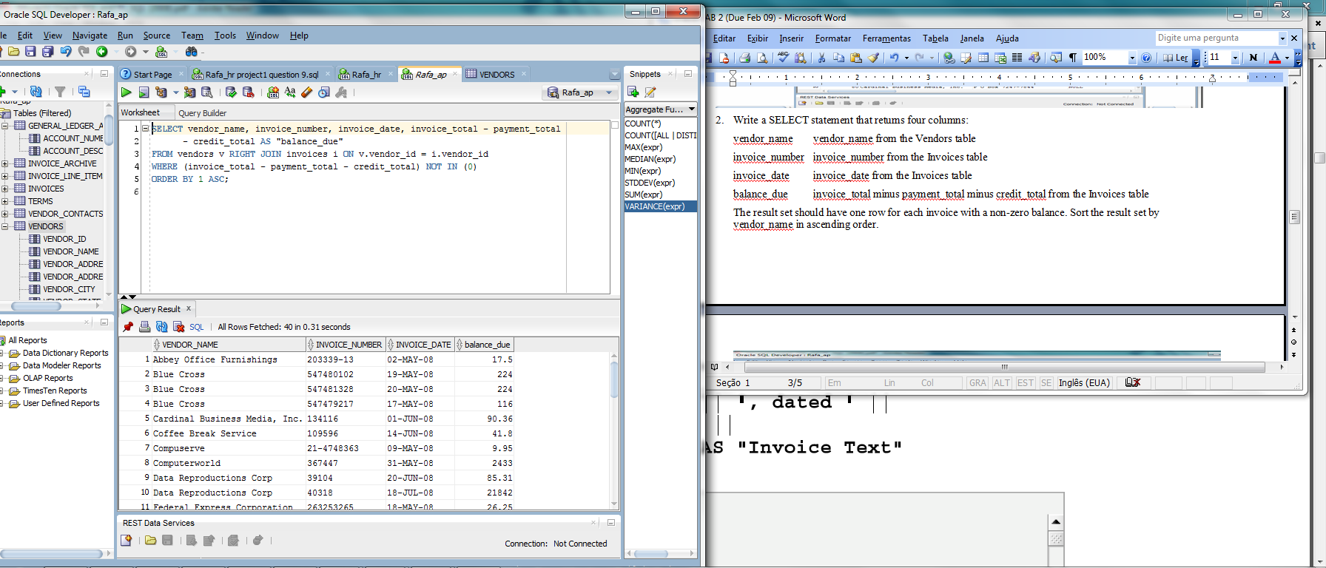
- Write a SELECT statement that returns three columns:
vendor_name vendor_name from the Vendors table
default_account default_account_number from the Vendors table
description account_description from the General_Ledger_Accounts table
The result set should have one row for each vendor, and it should be sorted by account_description and then by vendor_name.
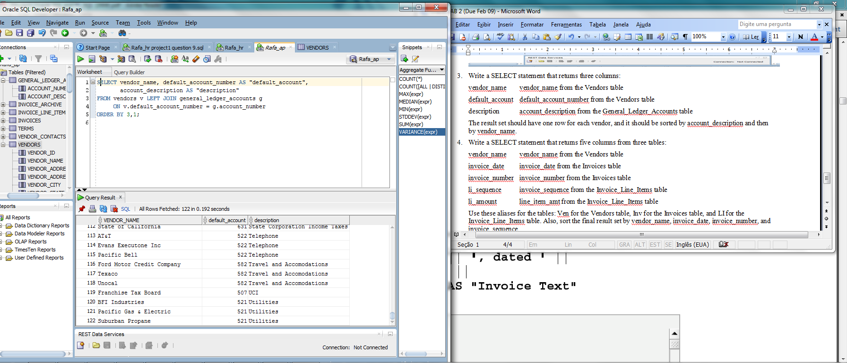

- Write a SELECT statement that returns five columns from three tables:
vendor_name vendor_name from the Vendors table
invoice_date invoice_date from the Invoices table
invoice_number invoice_number from the Invoices table
li_sequence invoice_sequence from the Invoice_Line_Items table
li_amount line_item_amt from the Invoice_Line_Items table
Use these aliases for the tables: Ven for the Vendors table, Inv for the Invoices table, and LI for the Invoice_Line_Items table. Also, sort the final result set by vendor_name, invoice_date, invoice_number, and invoice_sequence.
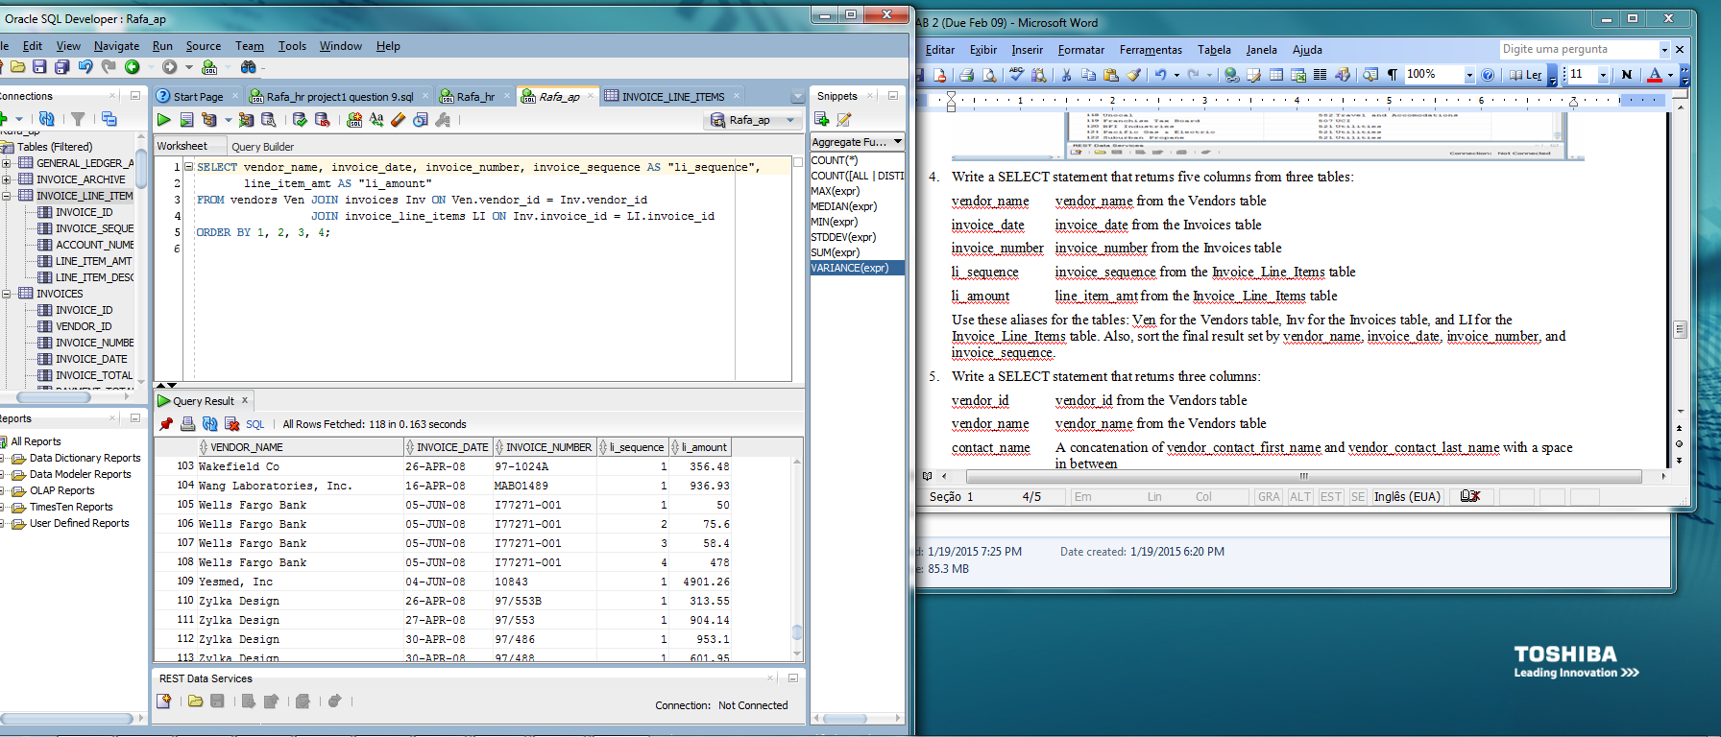
- Write a SELECT statement that returns three columns:
vendor_id vendor_id from the Vendors table
vendor_name vendor_name from the Vendors table
contact_name A concatenation of vendor_contact_first_name and vendor_contact_last_name with a space in between
The result set should have one row for each vendor whose contact has the same last name as another vendor’s contact, and it should be sorted by vendor_contact_last_name. Hint: Use a self-join.
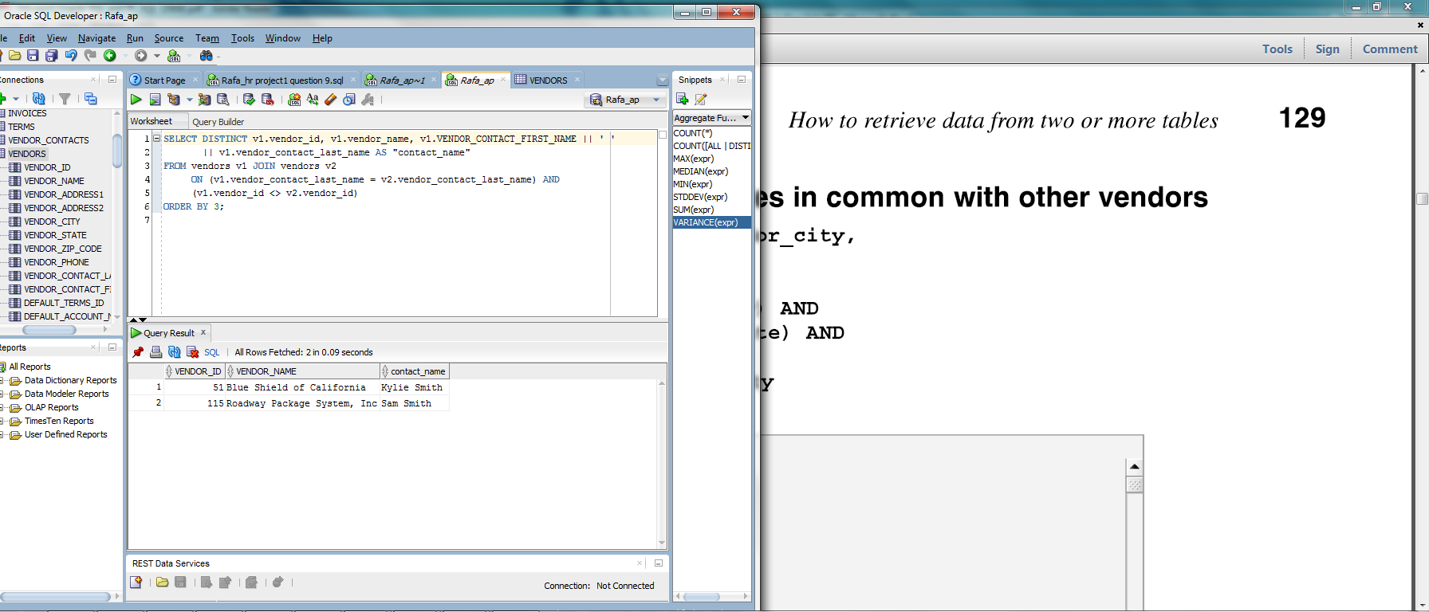

- Write a SELECT statement that returns two columns from the General_Ledger_Accounts table: account_number and account_description. The result set should have one row for each account number that has never been used. Sort the final result set by account_number. Hint: Use an outer join to the Invoice_Line_Items table.
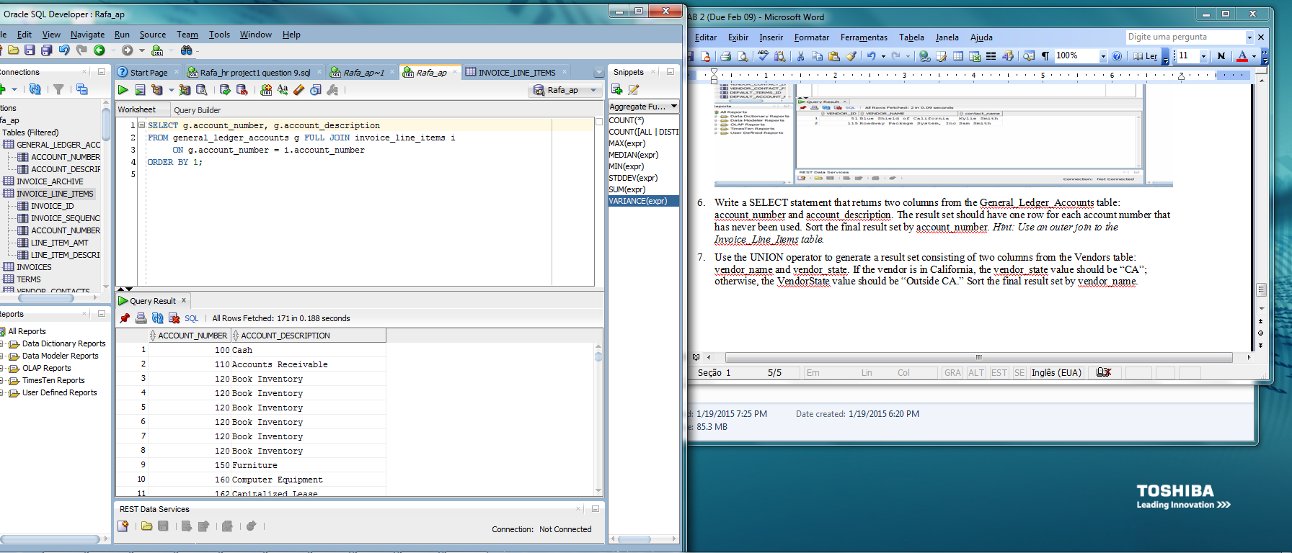
- Use the UNION operator to generate a result set consisting of two columns from the Vendors table: vendor_name and vendor_state. If the vendor is in California, the vendor_state value should be “CA”; otherwise, the VendorState value should be “Outside CA.” Sort the final result set by vendor_name.
